**DISEASE PREDICTION AND MEDICAL CHECKUP USING DEEP LEARNING**

**Dr.N.Pughazendi**

Professor

Department Of Computer science And Engineering

Panimalar Engineering College

[pughazendi@gmail.com](mailto:pughazendi@gmail.com)

Savaram Balajayanth, Vamsi Krishna.J, Saravanan.B

Department Of Computer science And Engineering

Panimalar Engineering College

[balajayanthsavaram@gmail.com](mailto:balajayanthsavaram@gmail.com) [vamsikrishnajtvb@gmail.com](mailto:vamsikrishnajtvb@gmail.com) 1999saravanan551@gmail.com

## ABSTRACT

Early diseases prediction plays an important role in improving healthcare quality and can help individuals avoid dangerous health situations before it is too late. The deep learning field has shown greater potential in applications such as disease prediction and drug response prediction. Deep learning techniques have continuously improved the accuracy of medical disease prediction as well as helped shape overall healthcare. Input is obtained in the form of numeric values for diseases such as cancer, diabetes, and cardiovascular conditions. Output results are acquired instantly in real-time in the form of a probable disease, its causes, and the aftermath. We will be using Deep Learning algorithms, mainly CNN and DNN, and Image Processing.

***KEYWORDS:*** Deep learning, CNN, DNN, Disease prediction

## INTRODUCTION

Accurately predicting diseases plays a significant role in public health, especially at the early stage which allows patients to take prevention treatments in time. With the growing volume and availability of electronic health records (EHRs), predictive modeling tasks for disease progression and analysis have obtained increasing interest from researchers. The EHR data are temporally sequenced by patient visits with each visit represented as a set of high dimensional clinical events. Mining EHRs is especially challenging compared to standard data mining tasks, due to their noisy, irregular, and heterogeneous nature. A conventional approach of disease prediction is the one-size-fits-all model. That is, using all available training data to build a global model, and then with this model, predicting the risk of diseases for each patient. The benefit of applying a one-size-fits-all model is that it captures the overall information of the entire training population. However, patients may have different phenotypes, different medical conditions, etc. Using a global model may miss some specific information that is important for individual patients. Thus, building a targeted, patient-specific model for each individual patient is urgent and important for personalized medicine. Recent studies show that personalized models can improve predictive performance over global models. A general framework for personalized prediction contains two stages: (1) measuring the similarity among patients, and (2) building a separate model for each patient using his/her similar cohorts. This framework is motivated by the working process of human doctors, i.e., after reviewing or recalling the diagnosed patients with similar diseases or symptoms, the doctors then carefully make decisions. If doctors can find similar patients, the probability of successfully curing this patient may improve a lot. Many similar learning methods have been proposed on healthcare datasets.

## EXISTINGSYSTEM

Disease prediction systems have been playing a significant role in the life of people, and it has been considered an important topic by many academics.Although prediction results achieved are promising, these traditional approaches are still far from being highly accurate and efficient. The existing systems are simple and effective but are extremely vulnerable to impact. Moreover, state-of-the-art methods can detect diseases pertaining to certain organs only while some severe conditions may go completely undetected. This could lead practitioners to false assumptions and improper diagnosis and treatments provided to patients

## PROPOSEDSYSTEM

We propose an end-to-end application that predicts Cancer, Diabetes, Heart disease using distinct techniques.The aim of developing this application with the help of Deep Learning algorithms is to immensely help to solve health-related issues by assisting the physicians to predict and diagnose diseases at an early stage.The accurate analysis by our proposed application benefits in early disease prediction, patient care, and community services.The proposed application is simple and it shows the good efficient performance.The overall accuracy of the proposed scheme has been evaluated with the traditional state-of-the-art models and the results from our proposed application show a higher accuracy rate. The proposed prediction model caters to this objective following a stepwise approach through cleaning, feature extraction, and classification.Initially disease dataset is taken as an input for the system for Diabetes, heart disease, and cancer datasets.Relevant elements are fed to the neural network by eliminating the irrelevant features using feature selectionAs the algorithms are selected, the symptoms are processed, and the most likely disease is given as an output. The performance of the network is dependent on the number of guidelines used which decide the behavior of the network.The input is given to the neurons which perform some operation to generate the output

## SYSTEMDESCRIPTION

Thefigurebelowismerelyasummaryofalloftheentitiesthat havebeenintegratedintothesystem.Itbriefly outlines how our proposed system's complete voting process will work, from the administratorinitiating a fresh ballot for election through numerous voters casting their votes. It also depicts theirinterrelationships and includes a series of decision-making procedures and steps. This graphic alsoexplainsfunctionalcorrespondences.

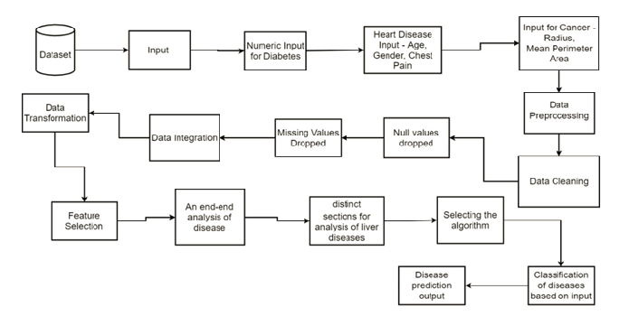Fig:1SystemArchitecture

Themodulesinvolvedare

* Getting the Input
* Cancer, Diabetes Heart Disease Prediction
* CNN for Image Classification
* Logistic Regression for Numeric Input
* End to End Diagnosis

**Getting the Input**

Initially, the disease dataset is taken as an input for the system for Diabetes, heart disease, and cancer datasets. Relevant elements are fed to the neural network by eliminating the irrelevant features using feature selection. The input is given to the network which performs some operations to generate the output. Inputs for various diseases are given as below –

Prediction of cancer disease via perimeters such as radius mean perimeter area

Prediction of Diabetes via blood glucose, thickness (numeric values)

Prediction of Heart disease via - chest pain type, age, gender (numeric)

To predict Malaria and Pneumonia we get the Image as input.

Prediction of liver diseases - Input

Age

Gender

**Cancer, Diabetes Heart Disease Prediction**

The diagnosis of heart disease depends on the detailed and precise analysis of the patient's clinical test data and an individual's health history.

Here, we’re using the Deep Neural Network, DNN algorithm to diagnose heart diseases, diabetes, and cancer-related ailments.

The DNN with multiple hidden layers is used hence the proposed model has high performance than ANN.

Input for Diabetes(Numeric Values)

Glucose: the concentration test in glucose

Input For Cancer-related Ailments

Radius

Mean Perimeter Area

**CNN for Image Classification**

In deep learning, a convolutional neural network (CNN) is a class of deep neural networks, most commonly applied to analyze visual imagery. It is a type of artificial neural network used primarily for image recognition and processing, due to its ability to recognize patterns in images. While CNNs are designed to solve problems with visual imagery, they also have many applications outside of image recognition and analysis, including image classification, natural language processing, drug discovery, and health risk assessments. CNNs also help provide depth estimation for self-driving cars. A CNN is a powerful tool but requires millions of labeled data points for training. Convolutional neural networks are composed of multiple layers of artificial neurons. Artificial neurons, a rough imitation of their biological counterparts, are mathematical functions that calculate the weighted sum of multiple inputs and output an activation value.

**Logistic Regression for Numeric Input**

Logistic regression is an algorithm used to predict the probability of categorical dependent variables. The dataset imported will be divided into two parts, namely training data and testing data. Training data is used as a basis for building models. This type of analysis is used to understand the relationship between the dependent variable and one or more independent variables by estimating probabilities using a logistic regression equation. In this way, you can predict how likely it is that an event will happen or a choice will be made. In order to predict the output of a categorical dependent variable, logistic regression must first determine the category or class of the dependent variable. This can be accomplished through a simple calculation, which returns an estimate of how likely it is that any given value within that category(s) will occur. The probabilistic values returned by this equation are then used to generate a prediction for how different combinations of independent variables would produce this particular output.

**End to End Diagnosis**

For the analysis of all these diseases, we will create an end-to-end application that is able to analyze all of the input data for the diseases, process the data using distinct techniques, and then accurately predict the most likely disease which is given as output. The application will contain distinct sections for analysis of liver diseases, cardiovascular diseases, kidney-related ailments, cancer, pneumonia, and malaria. Not only just the disease, but the application would also predict the most likely disease based on the given input data. The application will be designed to predict the disease, mention the aftermath of the same, how can it be treated and also the factors or changes that caused the disease. The application will act as a virtual assistant in major clinical laboratories, healthcare centers and medical clinics. The proposed model is a dynamic web application for an end to end disease prediction and diagnosis.

RESULTS

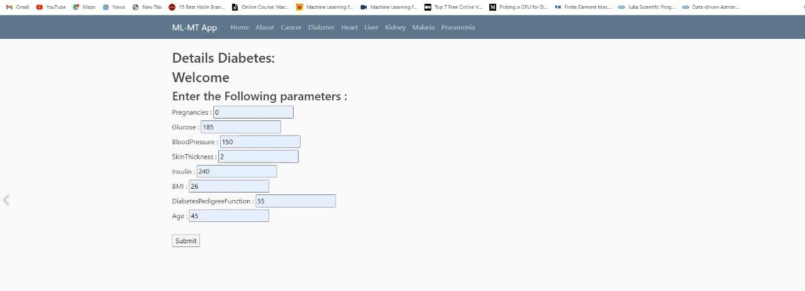

# Fig:2Diabetes – input

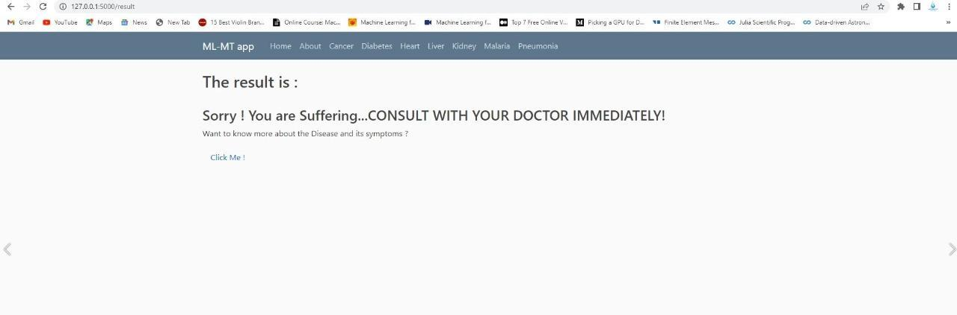

# Fig:3Disease predicted

## CONCLUSION

The results thus justify the effectiveness of the proposed method in disease prediction.Although the results are promising, the datasets being used are relatively smaller in comparison to the big data culture predominant in the present day and age.Thus, the research’s future path will be to test the proposed model on large-high-quality datasets to check the effectiveness and reliability of the proposed model.Our proposed methodology helps to improve the accuracy of diagnosis and is greatly helpful for further treatment.This work will be useful for identifying the patients who suffer from heart disease. When a patient is predicted with a positive result their reports and data can be closely analyzed.In future enhancements, the accuracy has to be tested with different datasets and to apply other AI algorithms to check the accuracy estimation.

## REFERENCES

[1] LivaFaes; Xiaoxuan Liu; Pearse A Kean, “A comparison of deep learning performance against health-care professionals in detecting diseases from medical imaging: a systematic review and meta-analysis”, The Lancet Digital Health, Volume 1, Issue 6, October 2019

[2] M. Chen, Y. Hao, K. Hwang, L. Wang and L. Wang, "Disease prediction by machine learning over big data from healthcare communities", IEEE Access, vol. 5, no. 1, pp. 8869-8879, 2017

[3] Pushpa Singh; Narendra Singh; Krishna Kant Singh; Akansha Singh,” Diagnosing of disease using machine learning”,2021, Machine Learning and the Internet of Medical Things in Healthcare Pages 89-111, 2021

[4] Alexander Selvikvag; Lundervold; Arvid  Lundervold; Katarzyna Węgrzyn-Wolska, “An overview of deep learning in medical imaging focusing on MRI”, ZeitschriftfürMedizinischePhysik, Volume 29, Issue 2, Pages 102-127, May 2019,

[5] Yuanyuan Pan; Minghuan Fu; Biao Cheng;  Xuefei Tao; Jing Guo,“Enhanced Deep Learning Assisted Convolutional Neural Network for Heart Disease Prediction on the Internet of Medical Things Platform, IEEE Access ( Volume: 8), May 2020,

[6] hirajDahiwade;  Gajanan Patle; EktaaMeshram,”Designing Disease Prediction Model Using Machine Learning Approach”,2019 3rd International Conference on Computing Methodologies and Communication (ICCMC), 2019

[7] Durr-e-maknoon Nisar; MeshrifAlruily ; Sultan H. Al Motor; Rashid Amin,“Healthcare Techniques Through Deep Learning:Issues, Challenges and Opportunities”, 2019

[8] Jerome Thevenot; Miguel Bordallo Lopez; AbdenourHadid,“A Survey On Computer Vision For AssistiveMedical Diagnosis From Faces”, IEEE JOURNAL OF BIOMEDICAL AND HEALTH INFORMATICS, VOL. 22, No. 5, 2018

[9) RahataraFerdousi; M. Anwar Hossain; Abdulmotaleb El Saddik, “Early-Stage Risk Prediction of Non-Communicable Disease Using Machine Learning in Health CPS”, IEEE Special Section On AI And IoT Convergence For Smart Health, July 2021

[10] Alice Othmania; Abdul Rahman Taleb; Hazem Abdelkawy; Abdenour Hadid, “Age estimation from faces using deep learning: a comparative analysis”, Computer Vision and Image Understanding, Volume 196,  102961, July 2020